Module 8: Building a Housing Price Predictor Model

Wilson Shealy

MIS-470: Data Science Foundations

Dr. Wibbenmeyer

March 7, 2021

**1a) Calculate the mean, median, maximum, minimum, and SD.**

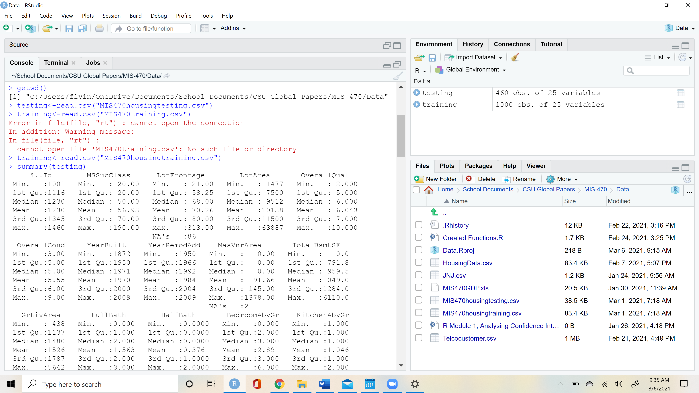

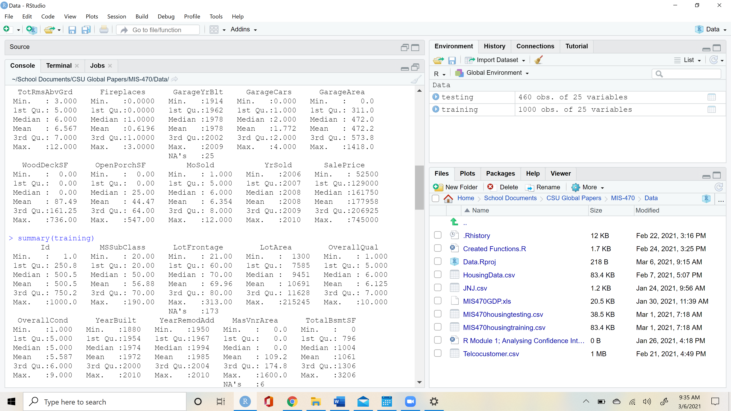

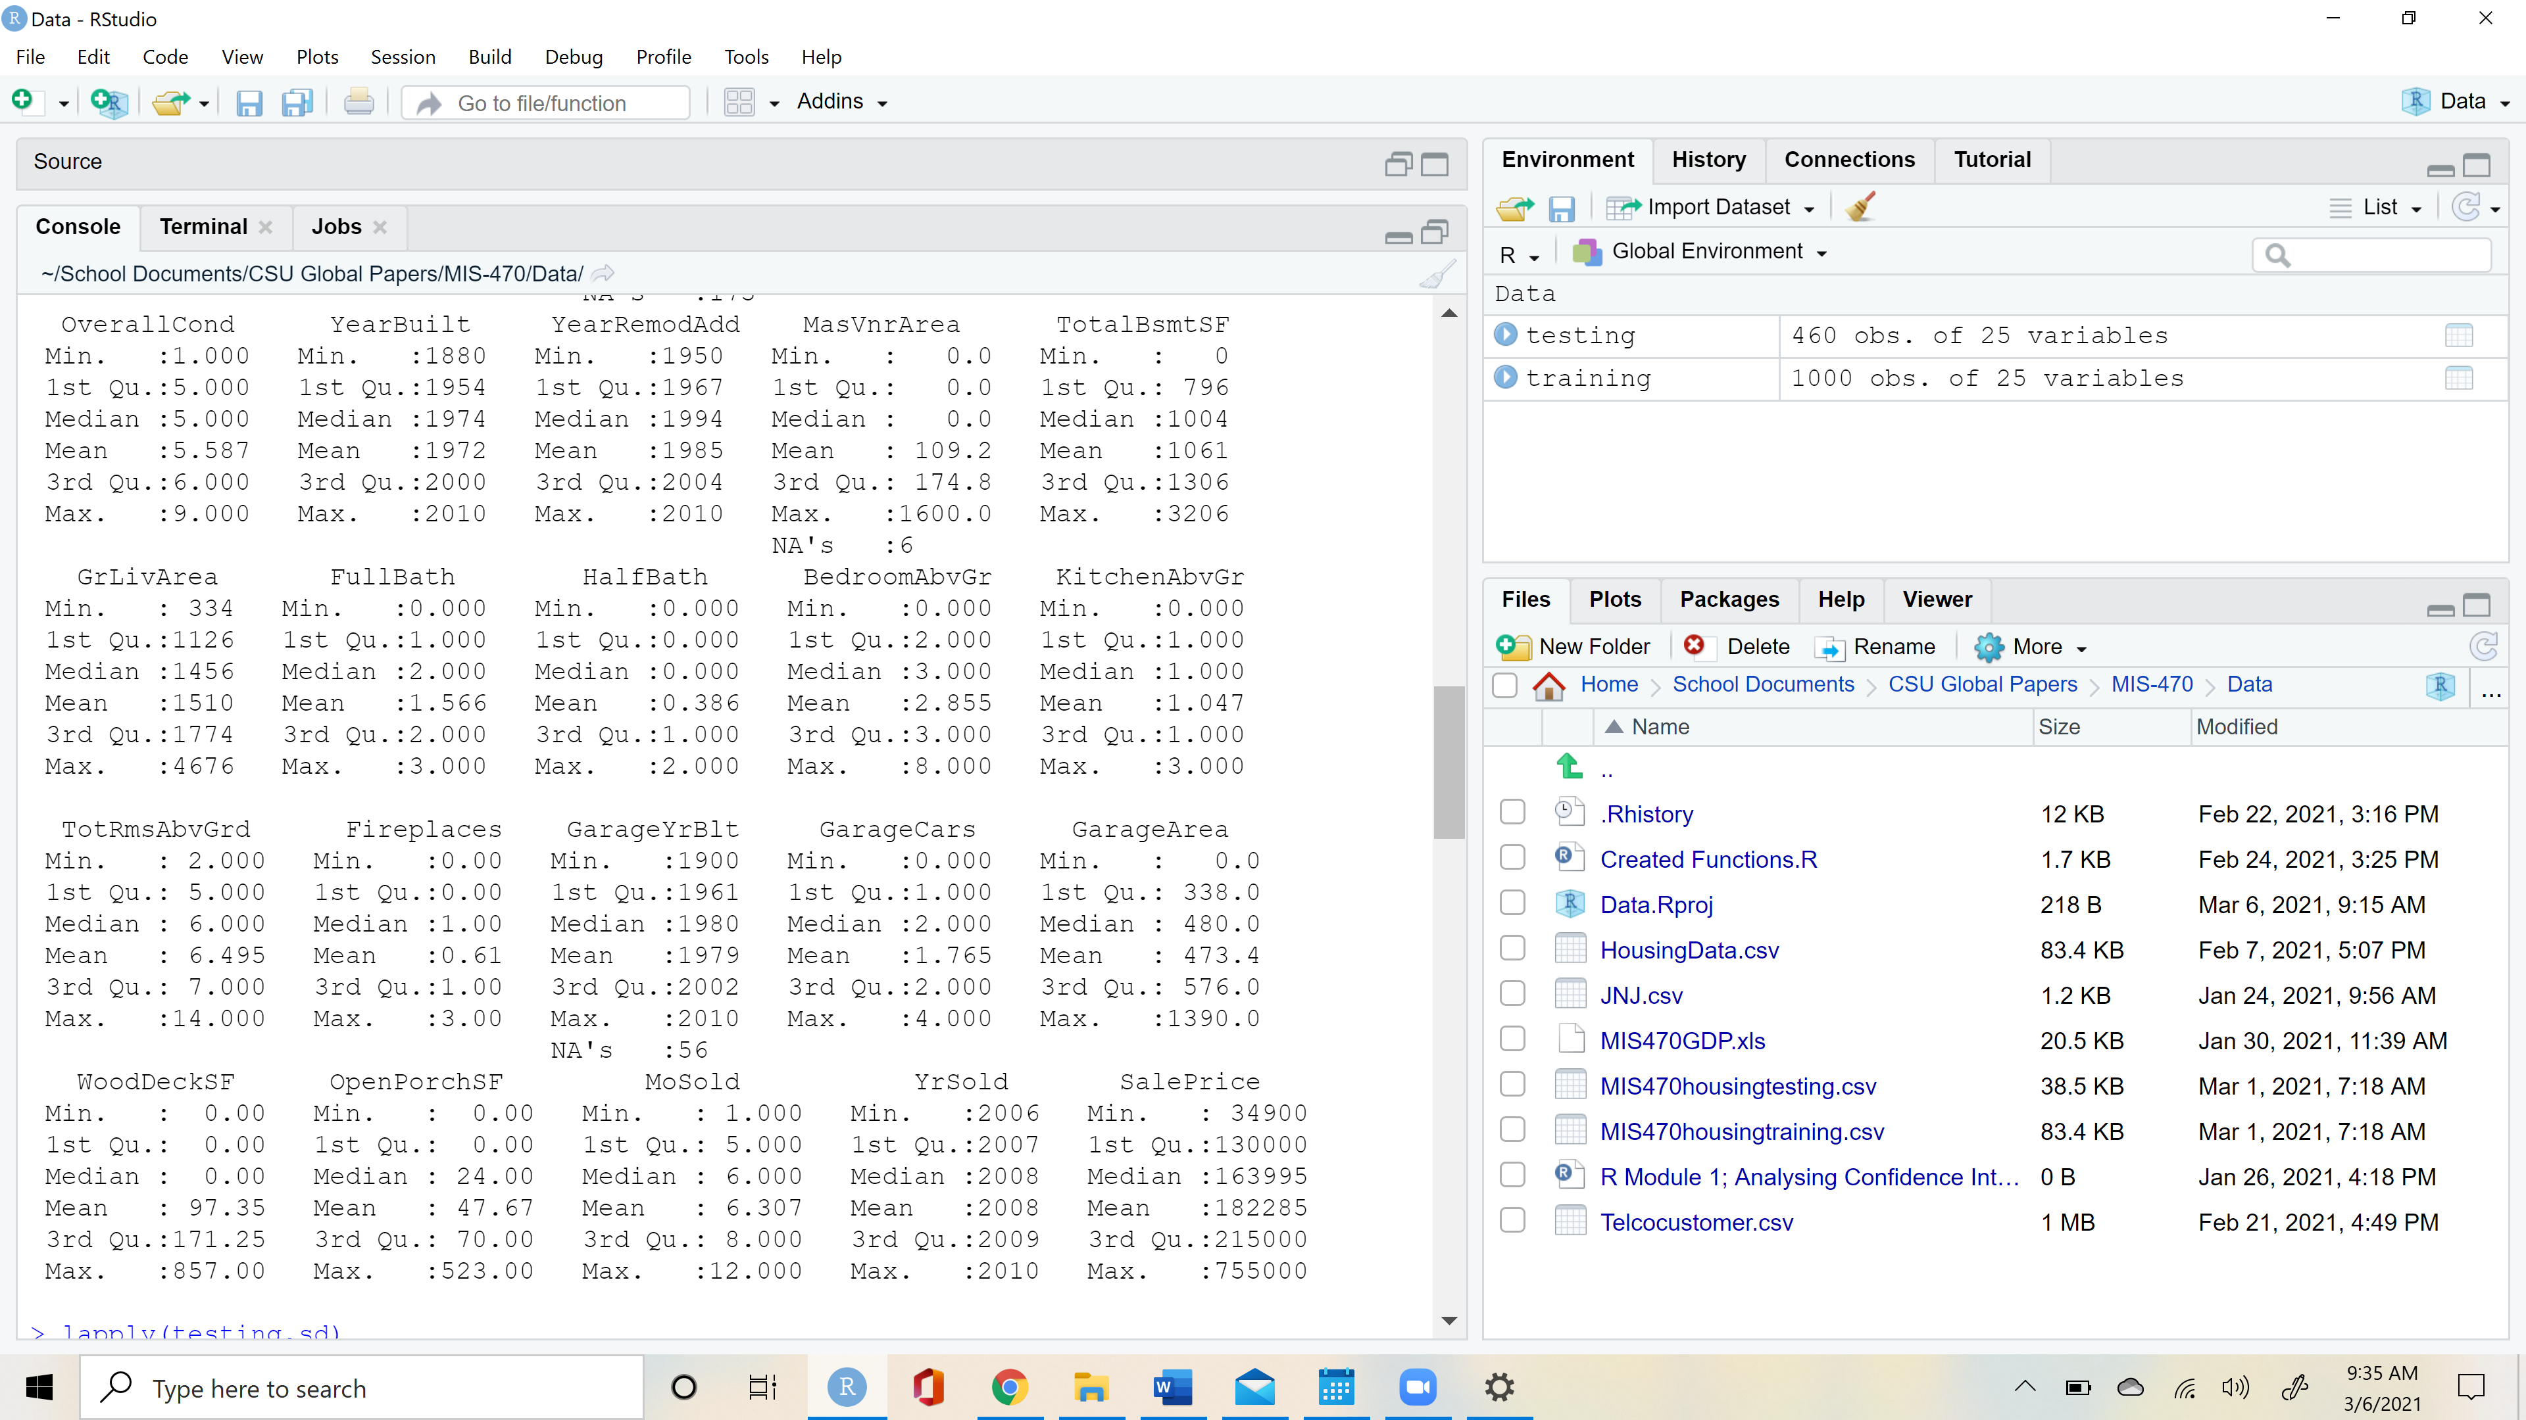

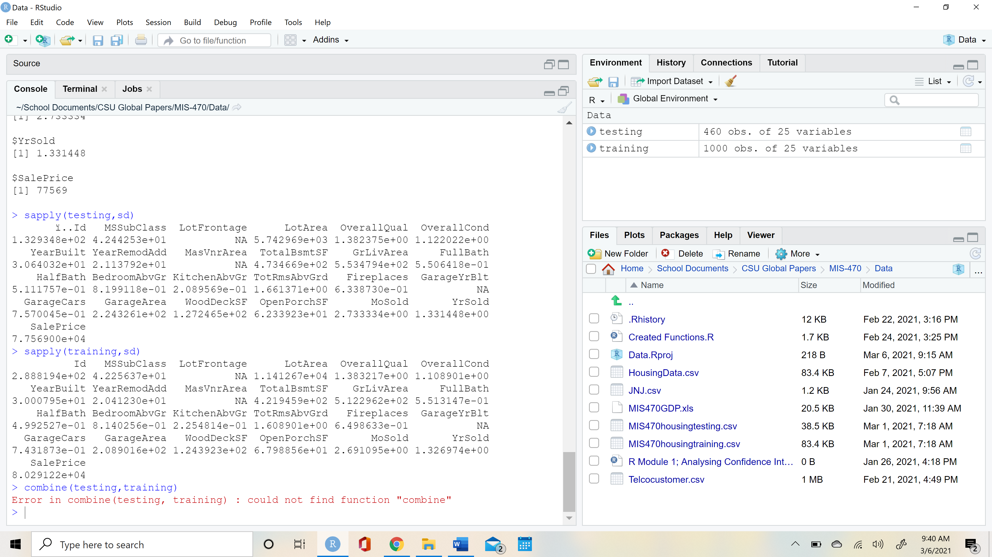

**1b) Show a histogram of training and testing sale price and compare them to one another.**

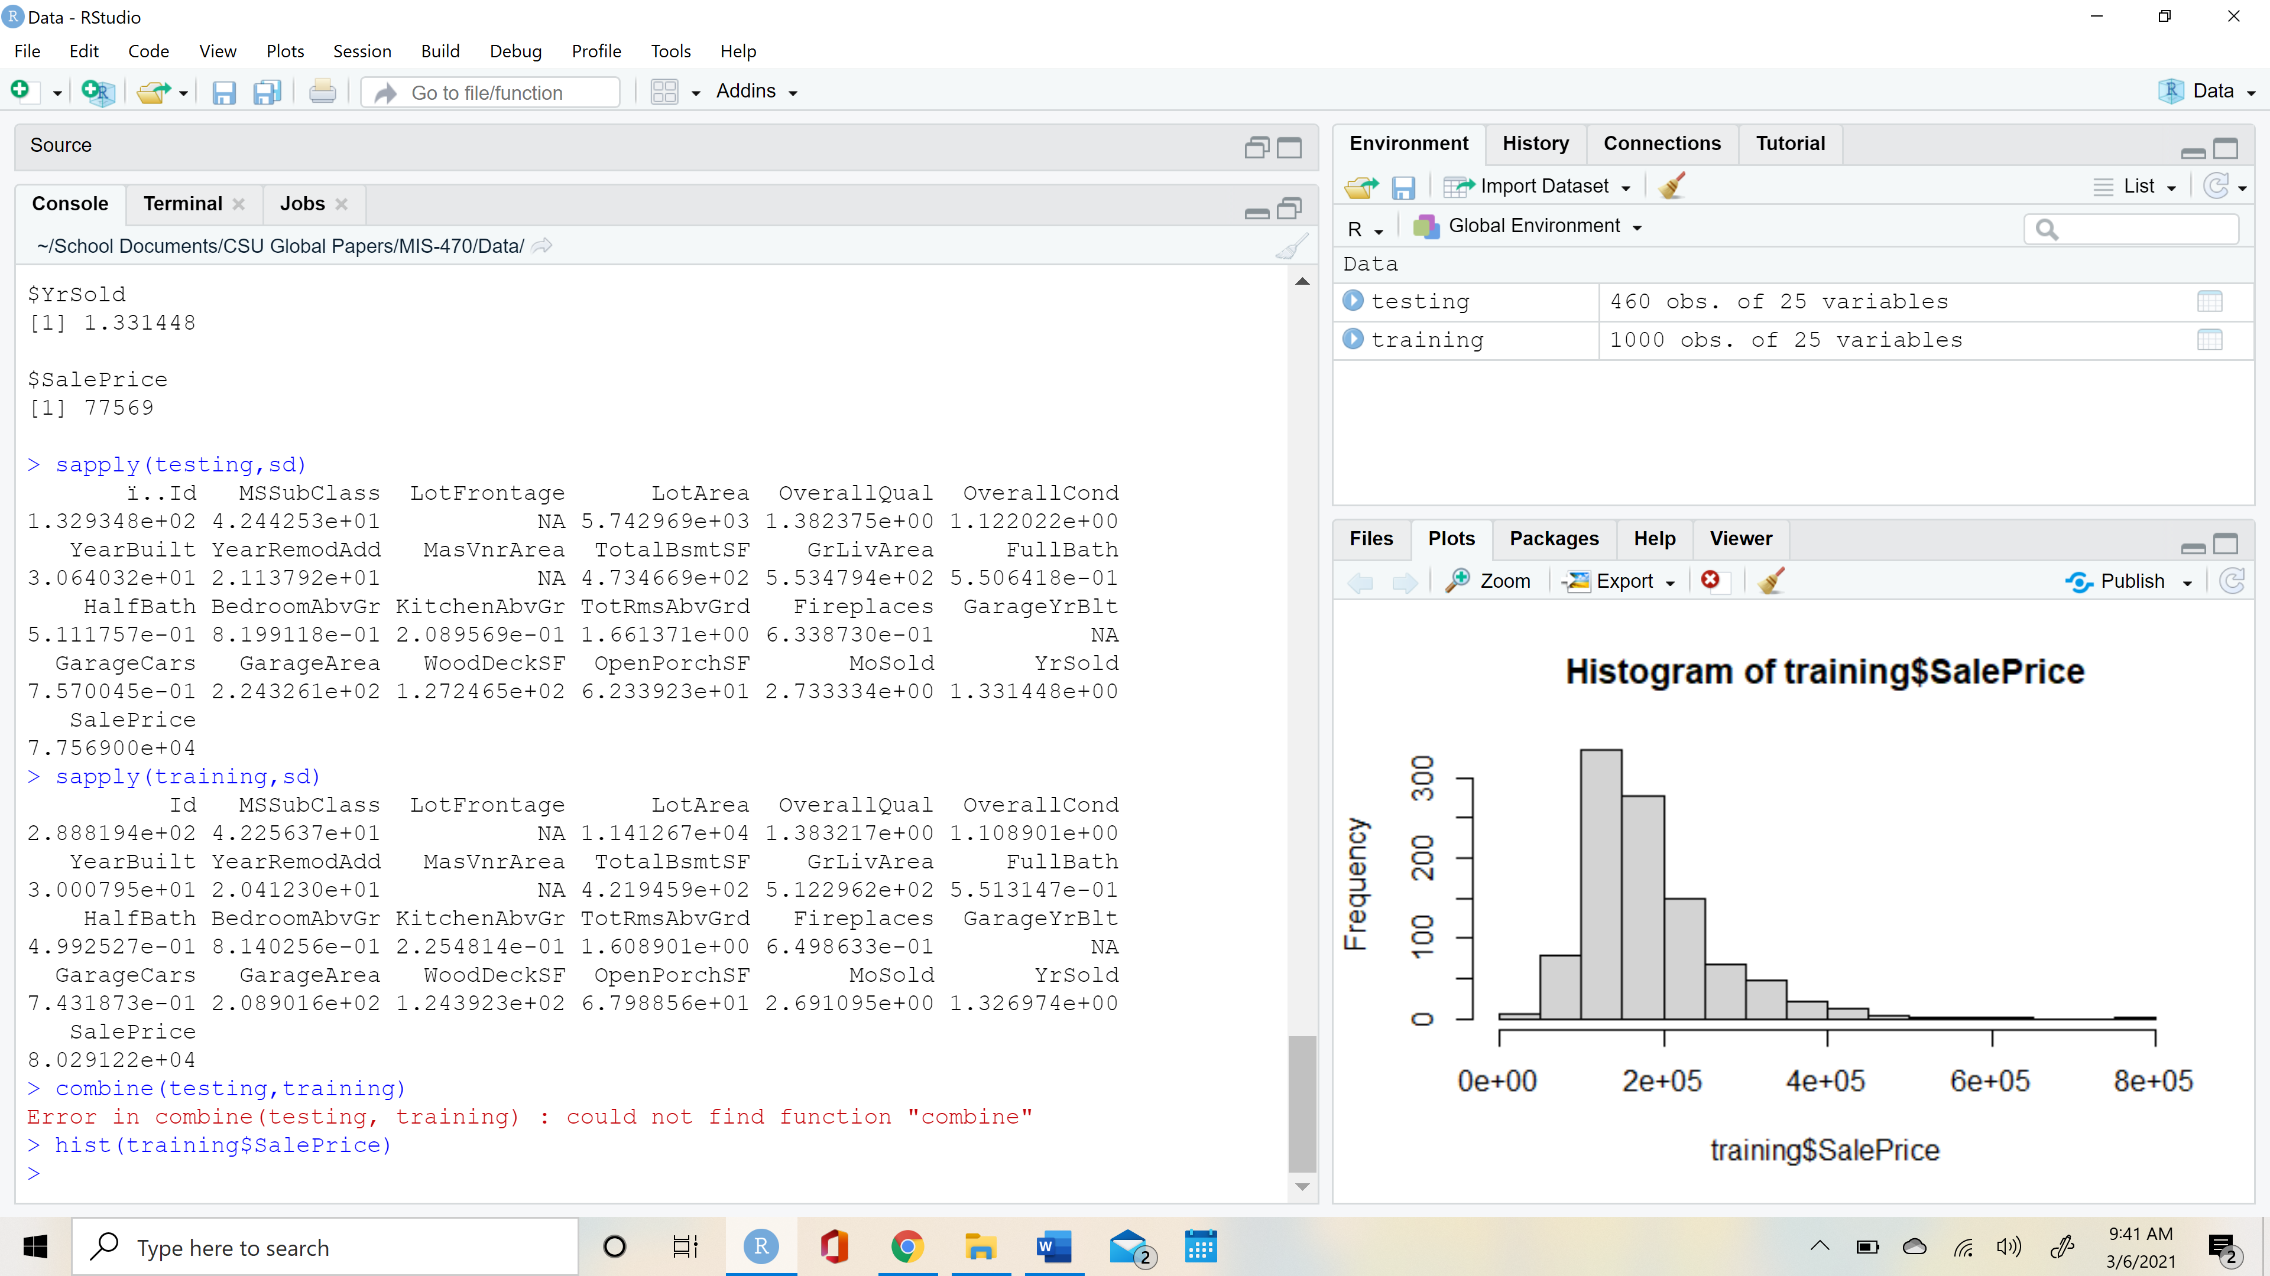

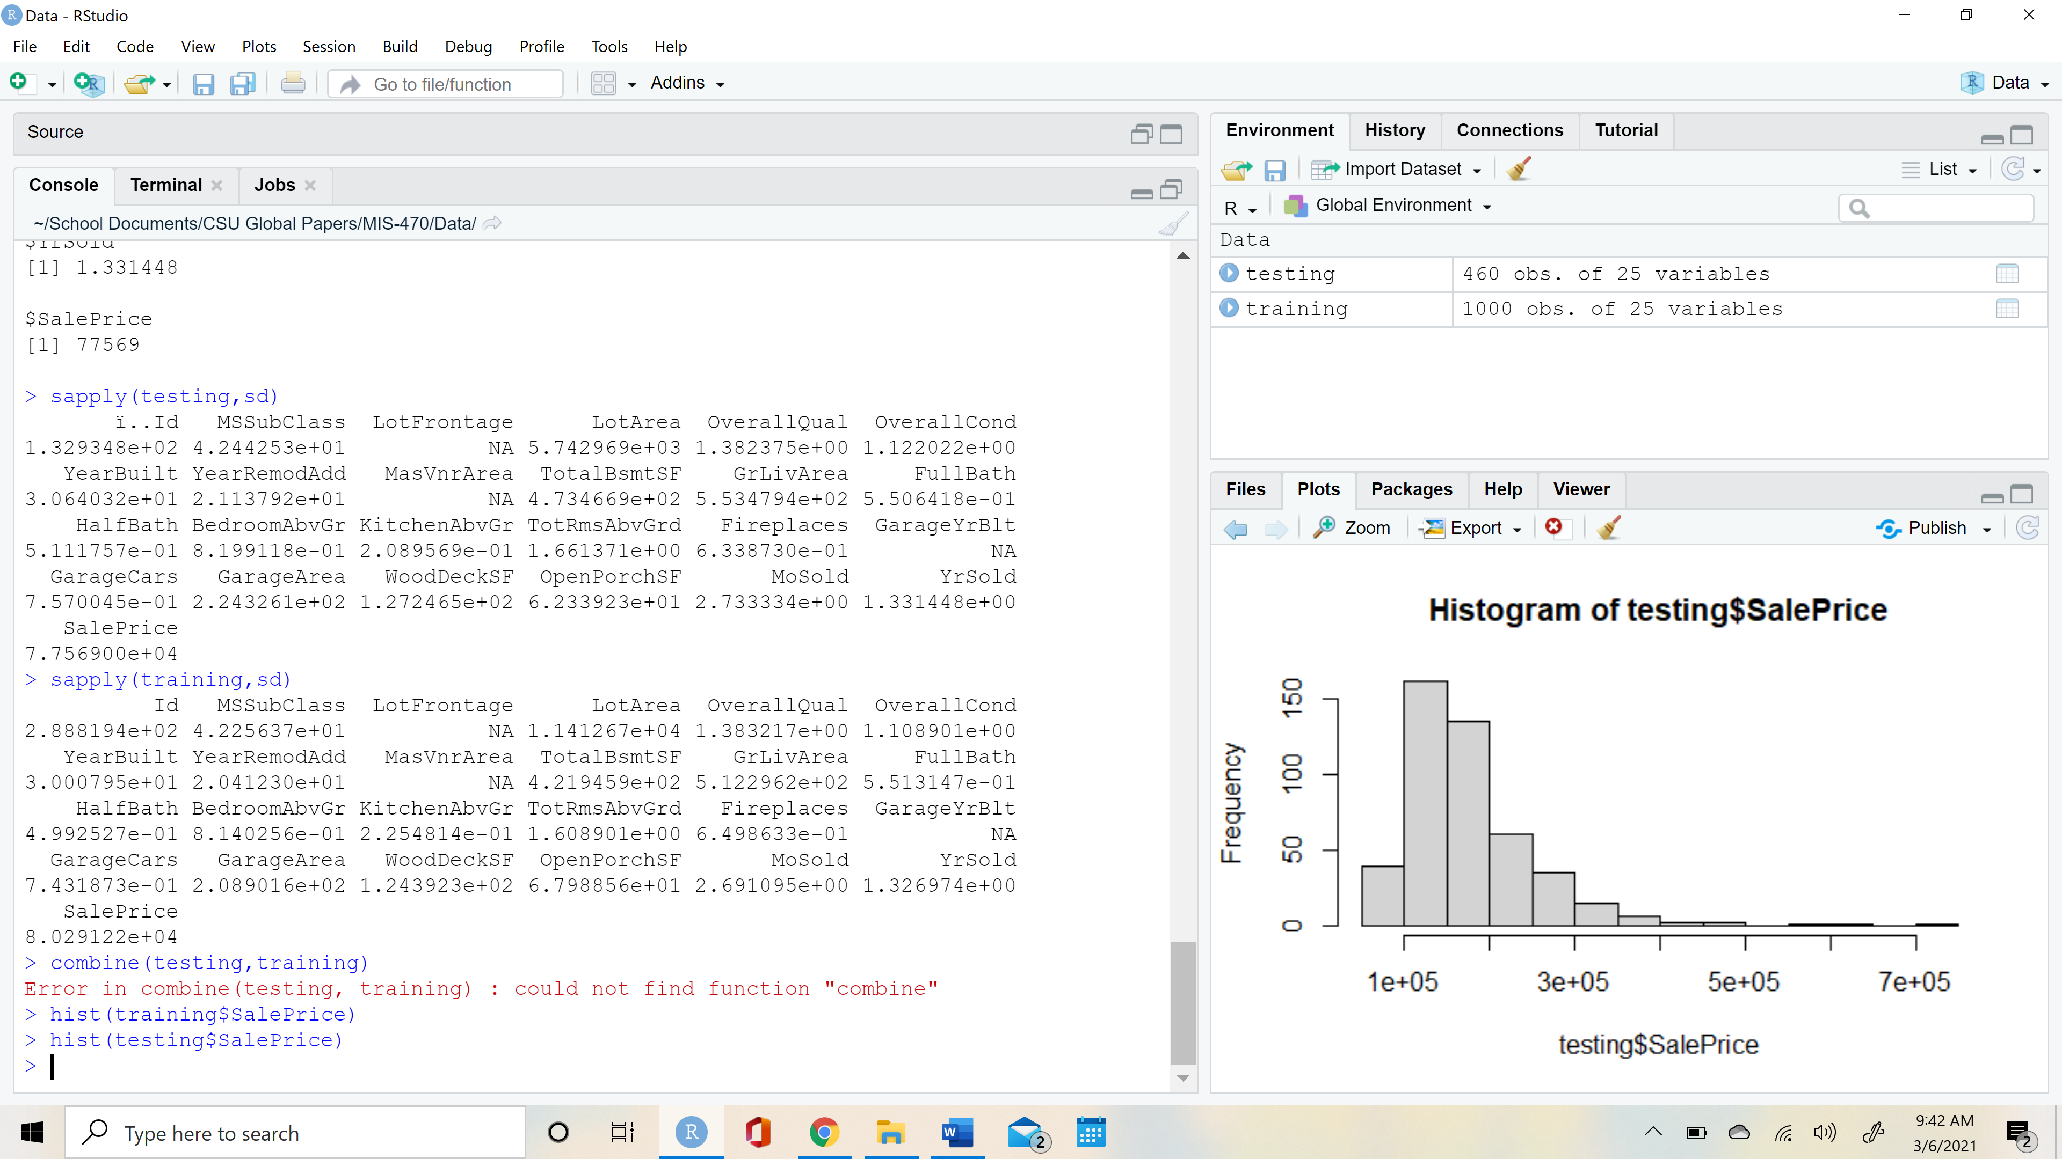

The testing and training sale price data sets are similar. They are both positive right skewed and have a majority of their values under $200,000. One of the biggest differences is the frequency. The training data is roughly twice the size of the testing data. In the <$200,000 category, the training data has a value of ~700 and the testing data has a value in the same category of ~300. This is consistent with the standard 66%/33% training vs testing ratios. While this doesn’t fit the recommended 80%/20% ratio for large datasets, it should be fine for this smaller data frame (Salzberg, 1997).

**2) Combine the two datasets housing.training.csv and housing.testing.csv. This can be done in R by using the function combine(). Create a histogram of sale prices for the combined dataset and compare it with the histograms from training and testing datasets. Describe the similarities and differences.**

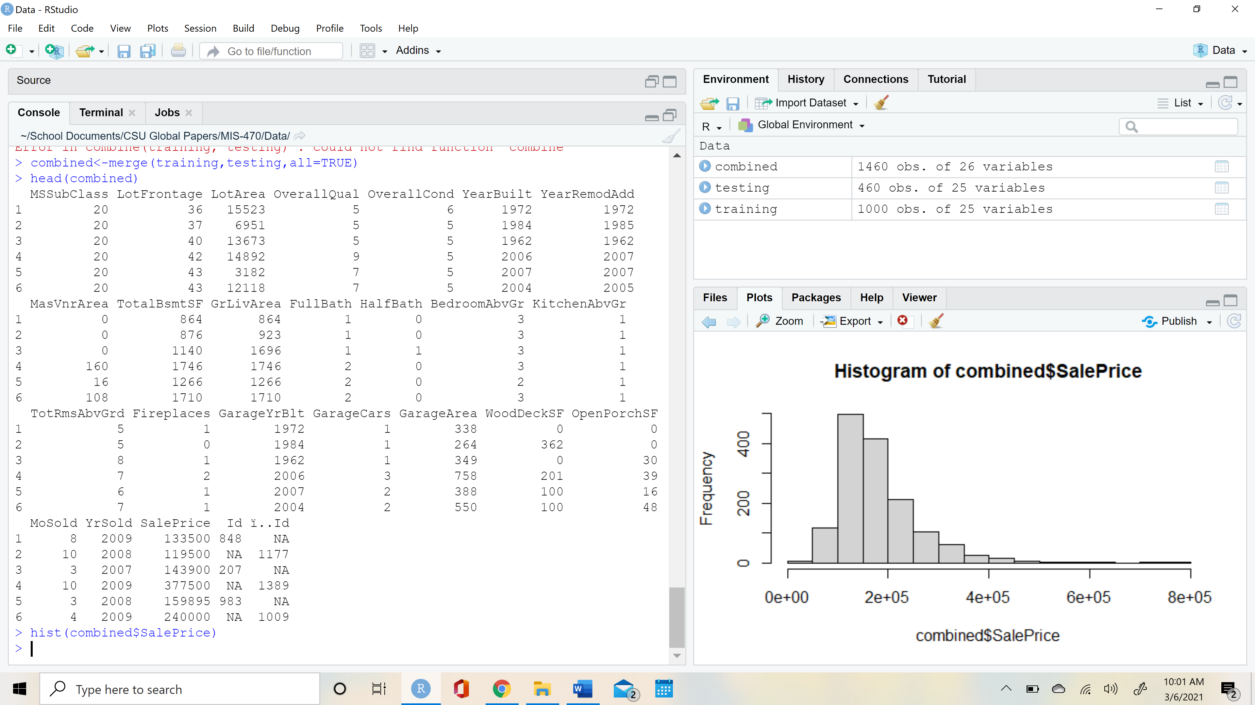

Just like the testing and training dataset, the combined dataset has a positive right skew and has most of its values under $200,000. As expected, the frequency of the values are equal to the combination of the testing and training dataset. We can see this by observing the total frequency of the values under $200,000. Whereas the testing data had values ~350 and the training data had values ~650 in this category, the combined data has values ~1000.

**3)Using only the dataset *housing.training.csv*, fit a linear regression model using all the explanatory variables and Sale Price as the response variable.**

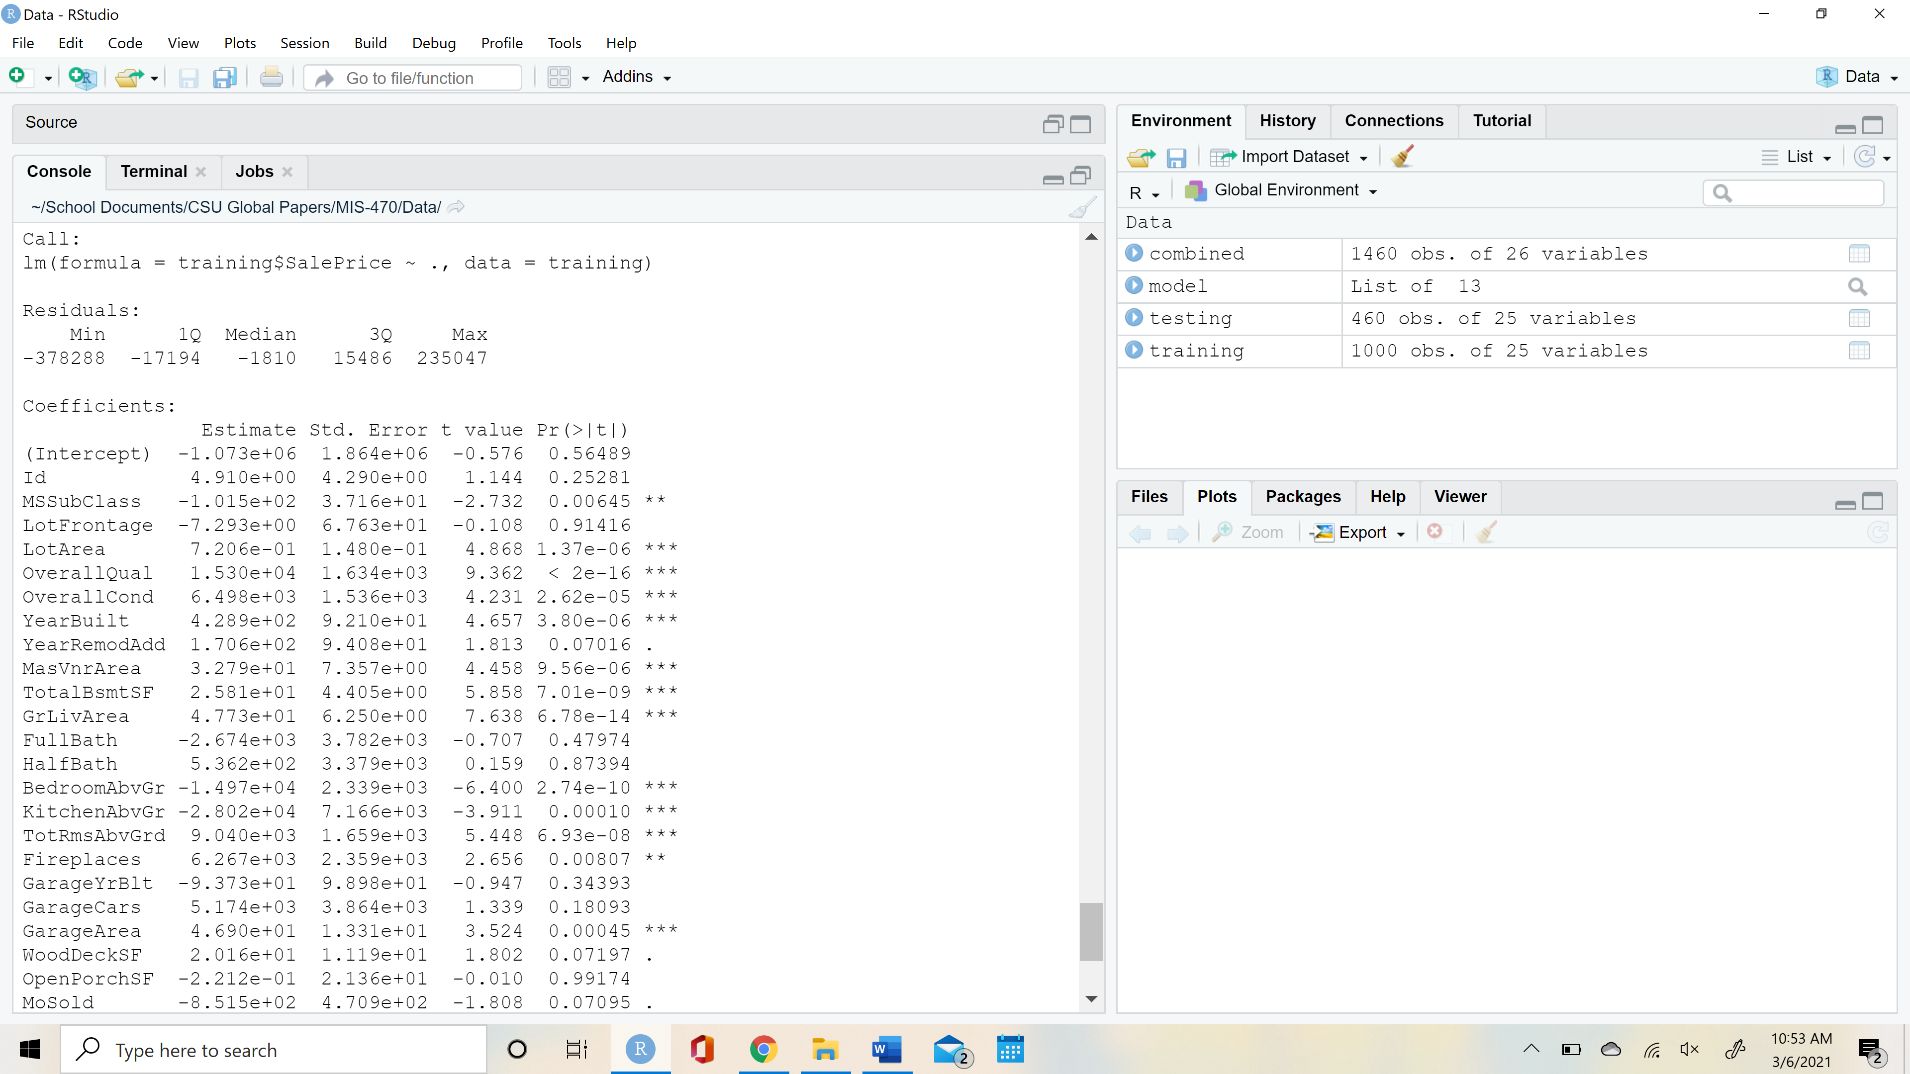

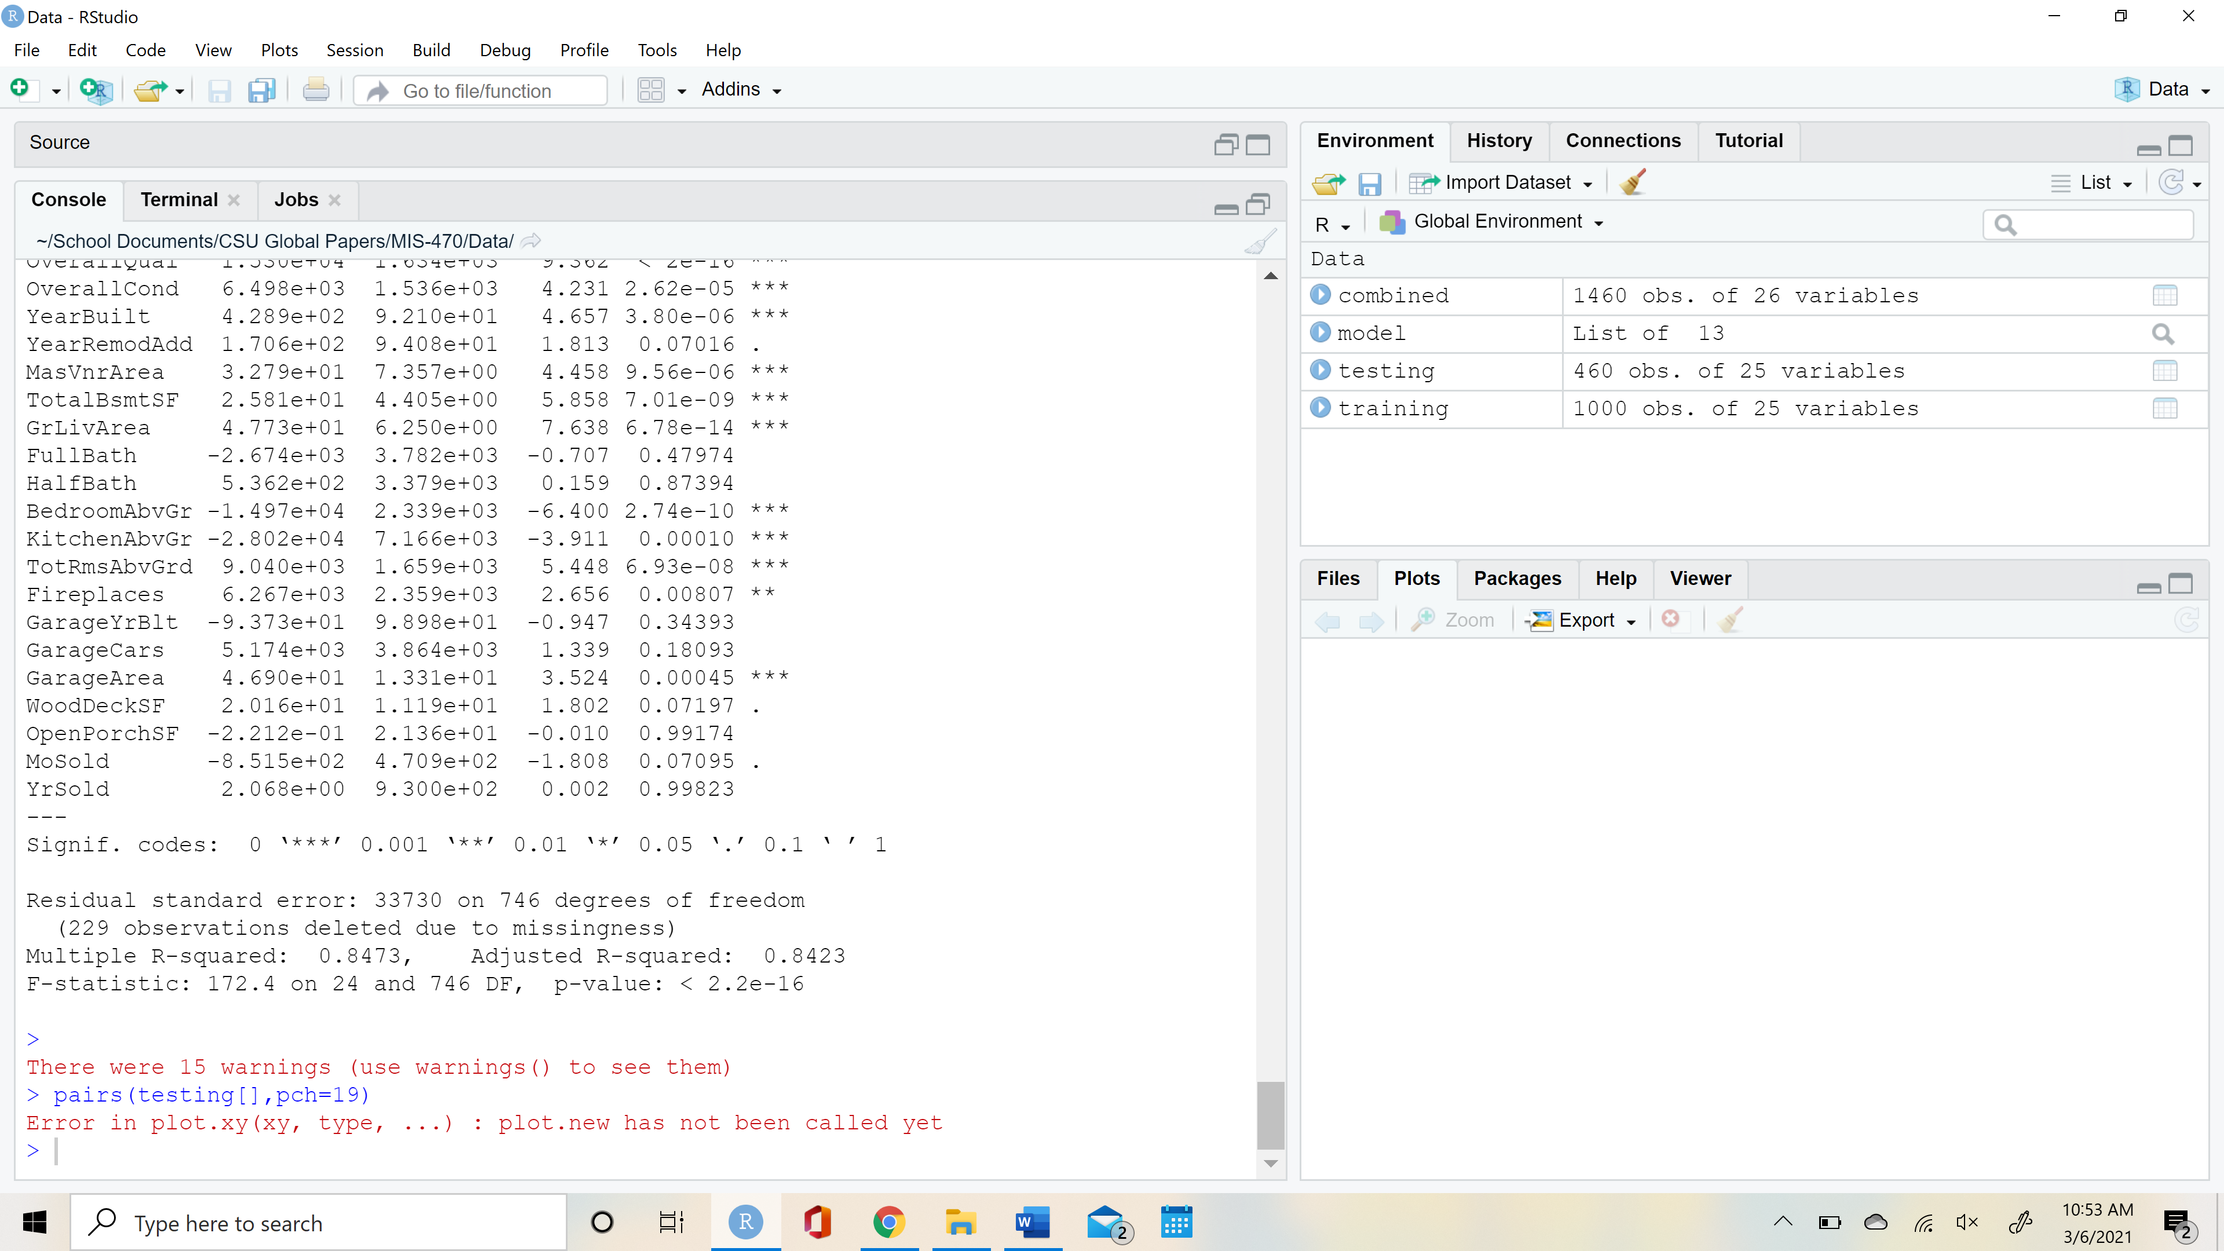

**4) What are the significant factors? How do these variables relate to the sale price? Interpret your estimated model.**

In the model I created, I determined the significant factors using two primary methodologies. I used the training dataset to train the model. Linear models were created by using Sale Price as the response variable in comparison to the 25 exploratory variables. Once the model was created, I was able to assess the p-values and the estimated slopes to assess which factors were significant. First, the p-values were analyzed to give insight into which values were statistically significant. Most of the data follows the 2-tailed methodology, so for all intents and purposes, any p-value under 0.05 gives us 95% confidence that the null hypothesis ‘variable = no effect on price’ can be rejected (Prabhakaran, 2017). 13 of the 25 variables had a p-value under 0.05, so for this interpretation I had to also use the estimated slope of the model line to find the most significant factors determining housing cost.

The slope of the model line quantifies the impact an explanatory variable will have on housing cost. Steep slopes indicate higher rate of change per unit, so for this analysis I focused on variables that had a low p-value and a steep estimated slope. The variables that had the greatest slopes, and therefore the highest impact on Sale Price, were Overall Quality (1.530e+04), Bedrooms Above Ground (-1.497e+04), Kitchens Above Ground (-2.802e+04), Total Rooms Above Ground (9.040e+03), and Overall Condition (6.498e+03).

Qualities that made the housing price increase were Overall Quality, Total Rooms Above Ground, and Overall Condition. Positive slope values indicate that as these values increased, so did sales price. Overall quality had the largest impact on price with a Sale Price increase of $15300.00 +/- $1634.00 for every rating increase of 1 point (scale 1-10). Qualities that made the home decrease in value were Bedrooms Above Ground and Kitchens Above Ground. These variables both had negative slopes, meaning that with an increase of 1 unit, Sale Price went down. Kitchens Above Ground is a variable that states how many kitchens a home has above ground level. The data is binomial, having wither 1 or 2 kitchens, so while it is highly significant, it is not as relevant as a variable such as Bedrooms Above Ground. Bedrooms Above Ground ranges from 0-5, and as the count of bedrooms increases by 1, the Sale Price falls by $28,020.00 +/- $7166.00.

The R^2 value for the model is 0.8423 which means that 84% of the variance in Sale Price can be explained using the predictor variables. This is a high value and means that the model is performing at a sufficient level.

An estimated intercept of -1,073,000 is the point where the linear regression model crosses the y-axis when x=0. While this statistic is relevant in some cases, for this case it is not relevant, since a Sale Price cannot realistically be negative in value.

**5) Remove all the rows with missing values (NA) from the dataset housing.testing.csv. The function complete.cases() can be used.**

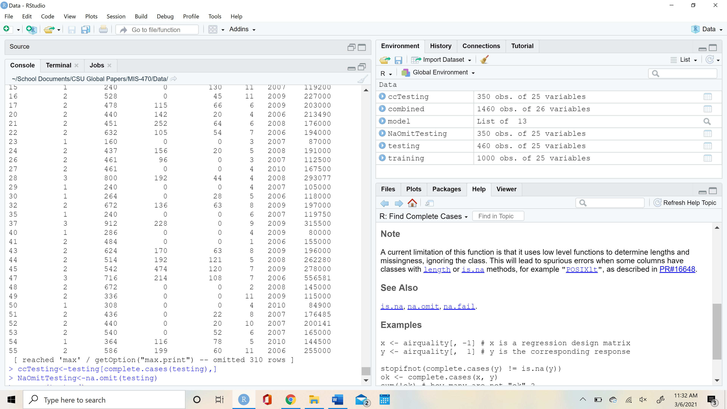

**5b) Using only the first 20 rows from housing.testing.csv, predict the sale price.  The R function predict() can perform this task.**

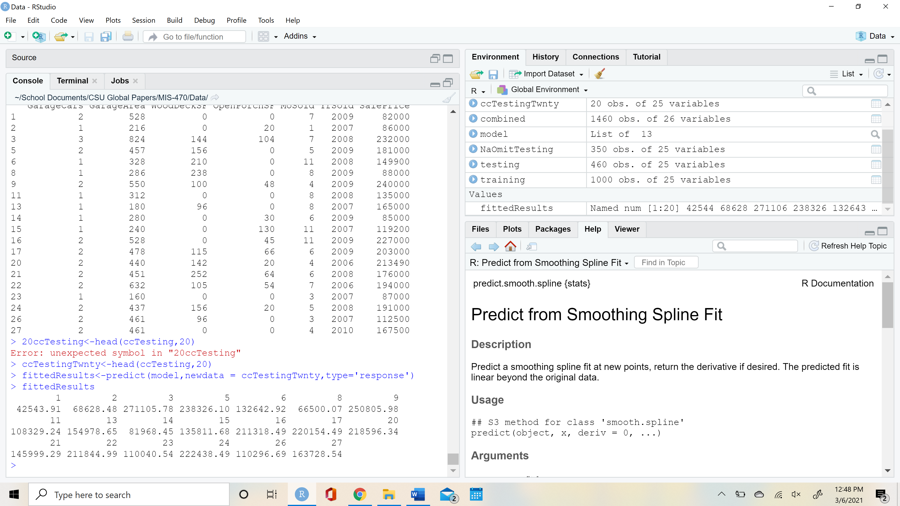

**6)** **Compare the predicted sale prices to the actual sale prices from the housing.testing.csv dataset (the first 20 rows). How good is your prediction?**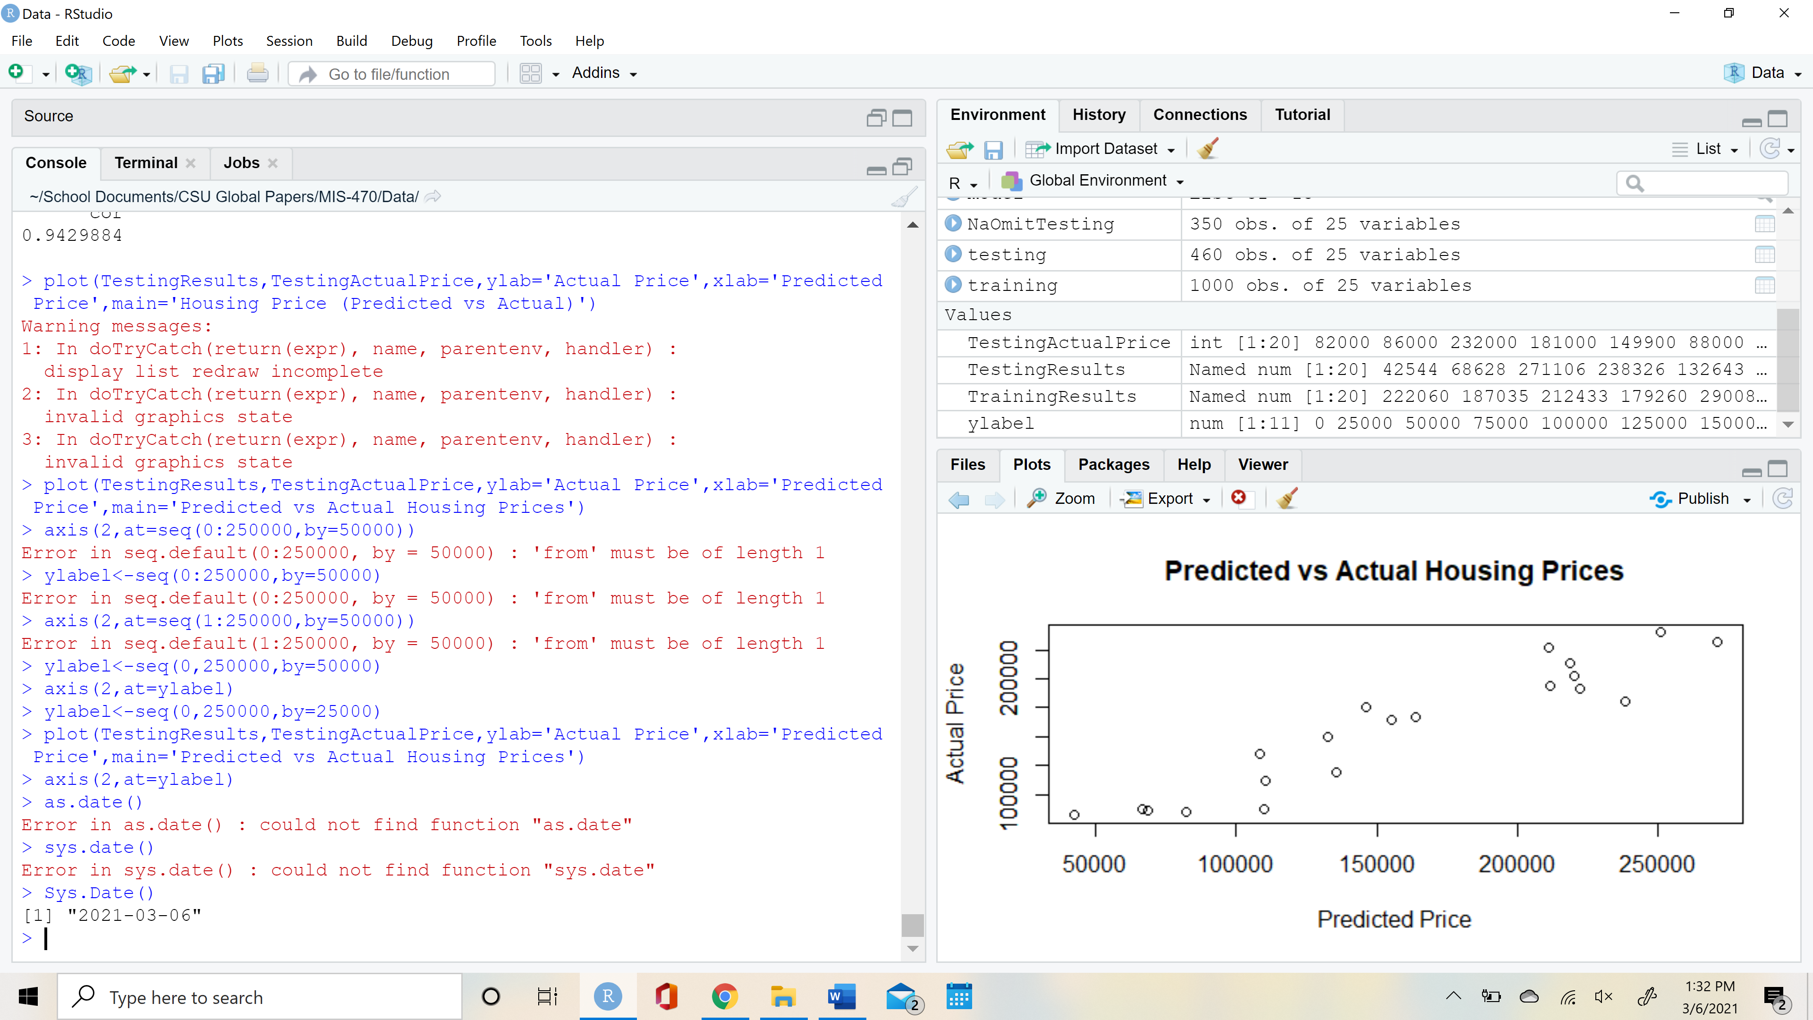

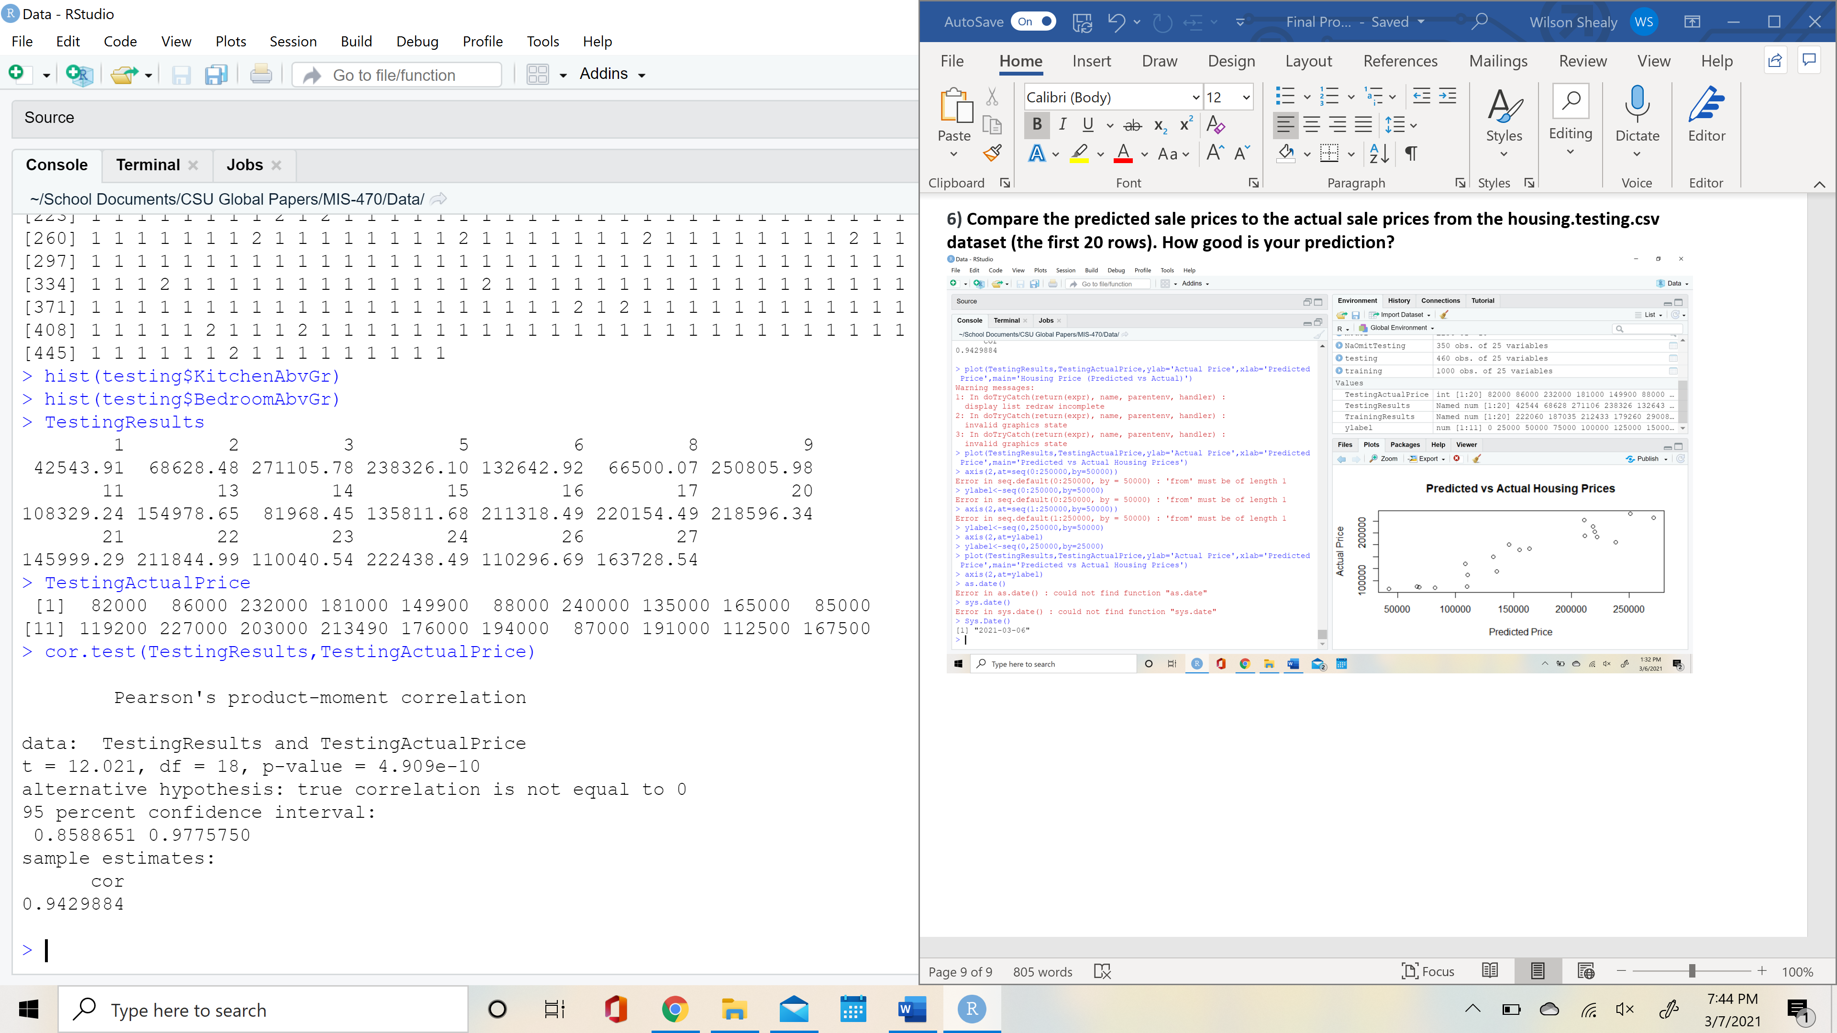

To compare the testing model sales price to the actual sales price, I used a correlation coefficient and a model to visualize the relationship. The Pearson’s correlation coefficient was 0.943. This indicates that there is a positive relationship between the data, and the values are strongly correlated with one another. We can see this positive correlation in the visualization. The data trends upward and has little variance. This relationship indicates that the model provides accurate estimates for housing Sale Price when provided with the 25 explanatory variables.

**Works Cited**

Prabhakaran, Selva. “Statistical Linear Regression with R.” Linear Regression With R, 2017, r-statistics.co/Linear-Regression.html.

Salzberg, Data Mining and Knowledge Discovery, 1, 317–327 (1997), "On Comparing Classifiers: Pitfalls to Avoid and a Recommended Approach".